cbca-global.org
global-commerce.org
cross-border-association.com

Ecommerce PL

Silne:
Społeczność - portal, konferencje, w miare ułożona struktura społeczności,

Słabe: Sembot promocja, brak interakcji,

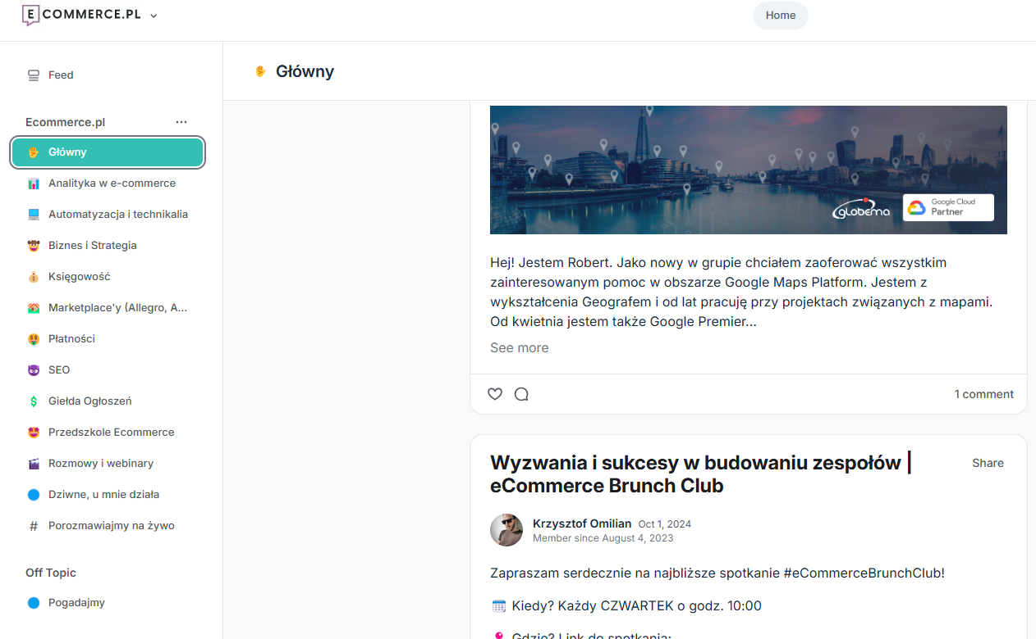

Positive:

Way they offer services: https://www.haendlerbund.de/en/

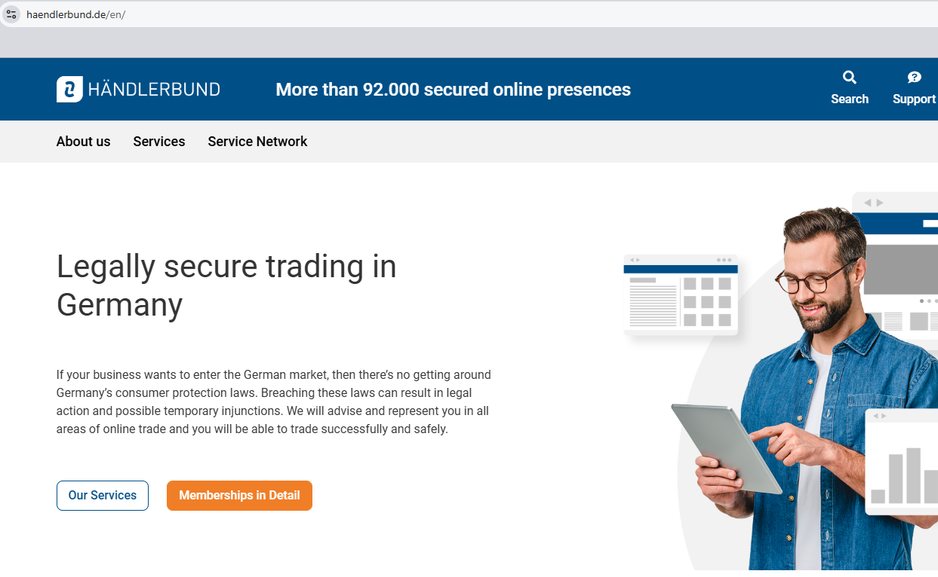

www.globaleea.com

Very small, asia - america oriented,

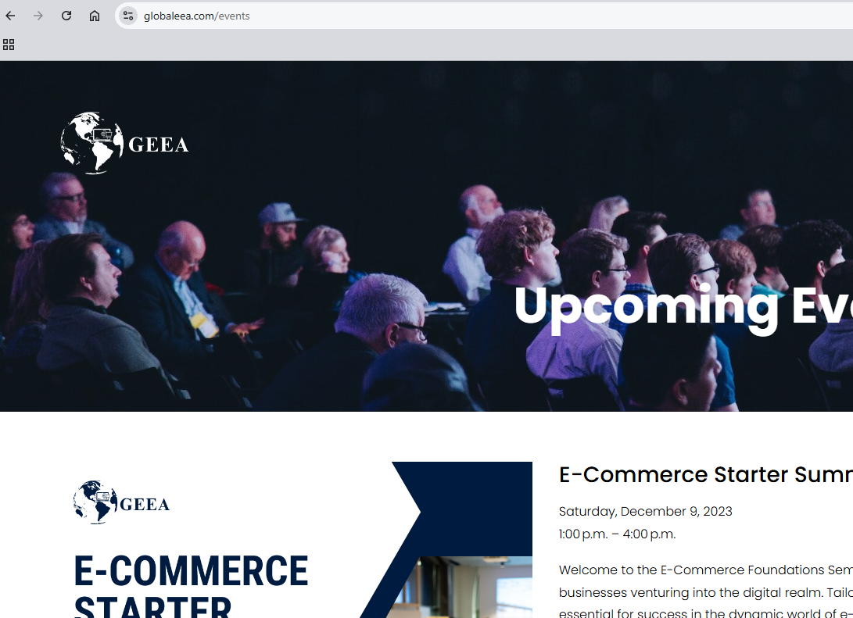
www.b2bea.org

Podcast, education certificates, events, list of companies, high profile association

https://www.cbcommerce.eu/about/mission/

https://www.ecommercebridge.com/ecommerce-expansion/

